Weekly report

1. **My *Goals* from last week**
   * Objective 1: Improve the Gauss gun design by making the components have a tighter fit, smoothing out the channels where the balls roll, and engraving SwarmControl.net and UH logos on the sides of the gun
   * Objective 2: Make a script for a video where I show how to put the gun together
   * Objective 3: Test if the design works for multiple-stage gun
2. **My *Accomplishments* this week**
   1. Project 1: Gauss gun

* The components of the gun fit better now, after several redesigns. They can’t be too tight because the width of the plastic varies so some pieces won’t fit. Also talked with people at the Keeland center for advice on how to smooth out the channels, and they said the only way is to turn the PPI all the way up
* Engraved the swag on the sides of the gun. With clear acrylic they look cool, but the channels look dirty. See Figure 1
* Tested gun with multiple stages, as shown in Figure 2. With two stages the magnets don’t move much, and the balls stay on the channel. The difference between one and two stages in terms of firing power is noticeable but not great, most likely due to friction due to the channels. More than two stages resulted in the magnets and balls flying out of place more often than not

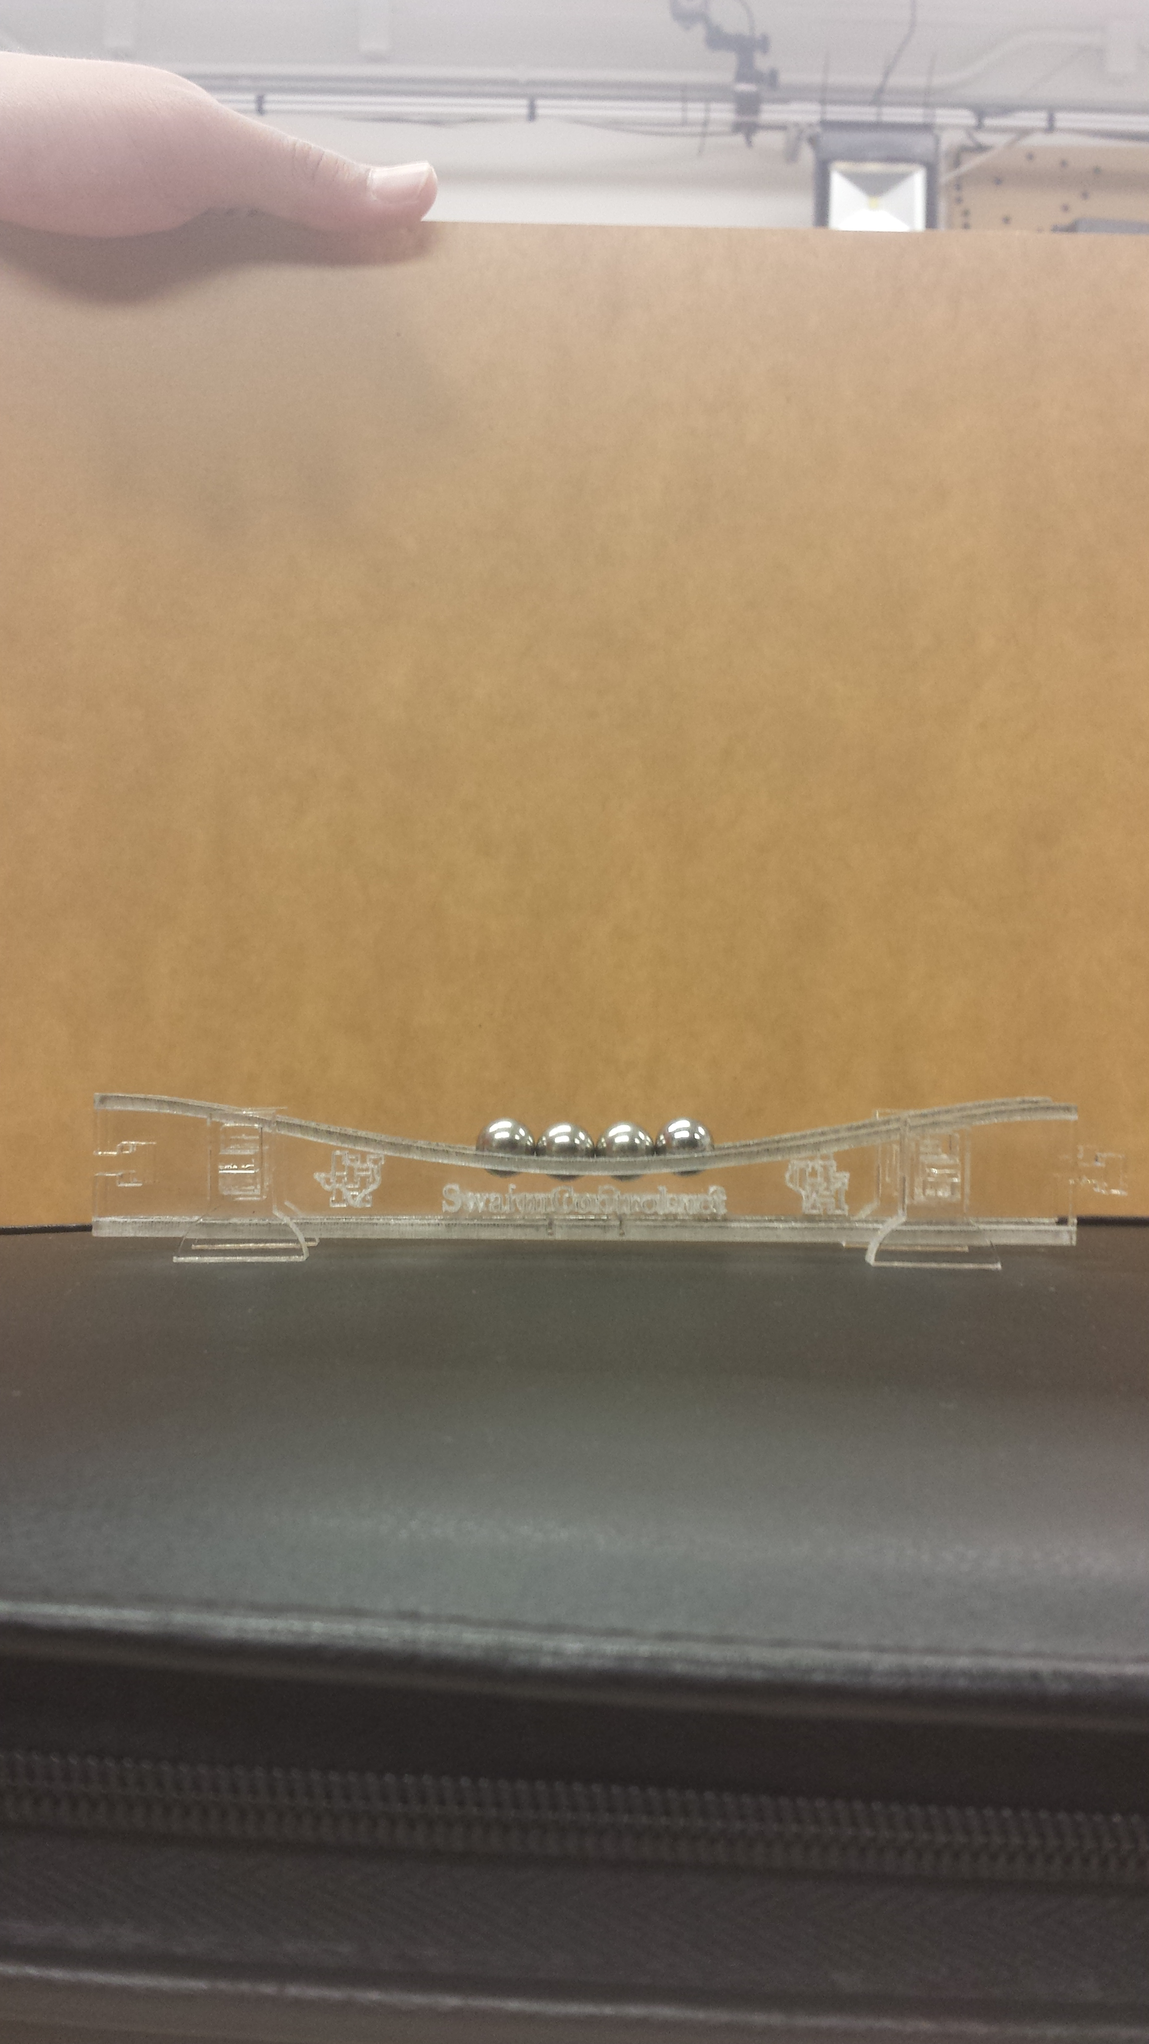

Figure 1. Gauss gun with engravings on the sides.

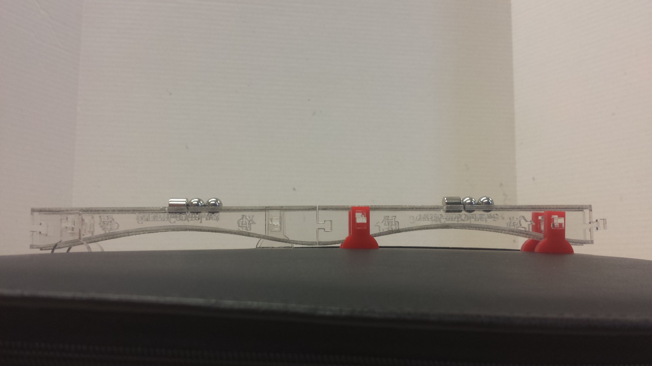

Figure 2. Two-stage Gauss gun with magnets in place. The stages connect much better now

1. **My *Goals* for next week**
   1. Project 1: Gauss gun

* Cut new pieces on clear red acrylic to see how much better they look
* Make script for video and at least begin making it

1. **What I need Dr. Becker to do:**
   1. Buy some clear red acrylic
   2. Meet with me so we can talk about the video and other stuff related to the lab (when are you available?)